# PUBLIC NOTICE OF SCHOOL BOARD MEETING

## OF MARSHALL PUBLIC SCHOOL DISTRICT

PUBLIC NOTICE is hereby given to the public and news media pursuant to Wisconsin Laws that a **SPECIAL MEETING: Committee of the Whole** of the School Board of Jt. School District No. 2, Village of Marshall, towns of Cottage Grove, Deerfield, Medina, Sun Prairie, and York, Dane County, Wisconsin will be held on **February 13, 2019** commencing at **5:00 PM** at the regular meeting place of said School Board in the District Office located in the Marshall Elementary School (617 Madison St.) in the Village of Marshall, Dane County, Wisconsin and that the preliminary agenda for said meeting is as follows:

### AGENDA

1. Call meeting to order

1. Roll call of the Board
2. Approval of agenda
3. Proof of giving public notice
4. Recognition of visitors
5. District Vision and Values
6. Consent Agenda
   1. Approve Resignations
   2. Offer Contracts / Letters of Employment
7. Reports
   1. Legislation and Advocacy
      1. WASB / WASDA Convention
   2. Curriculum and Instruction
      1. Discuss updated Graduation Policy #345.6
   3. Negotiations and Policy
      1. Update on Teacher Compensation Framework Work Group
   4. District Safety Team
      1. Safe/Secure School Entrances
8. Old Business
9. New Business
   1. Discuss Student Discipline: Suspension and Expulsion
   2. Discuss 2018-19 Calendar Revisions: 5 Inclement Weather Days
   3. Discuss 2019-2020 Budget Priorities and Planning
   4. Discuss Superintendent Evaluation Tool
   5. Discuss Referendum Presentation
   6. Discuss Important Conversations

11. Adjournment

These are the items known at this time. Adjustments may be made up to 24 hours prior to board meetings. Changes will be posted at each school site, Post Office, F&M Bank, and Marshall Public Library.

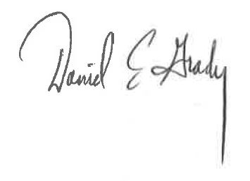

Designee of School Board President

DATED: February 8, 2019